# Century’s longest lunar eclipse July 27, 2018

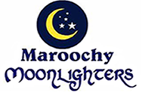 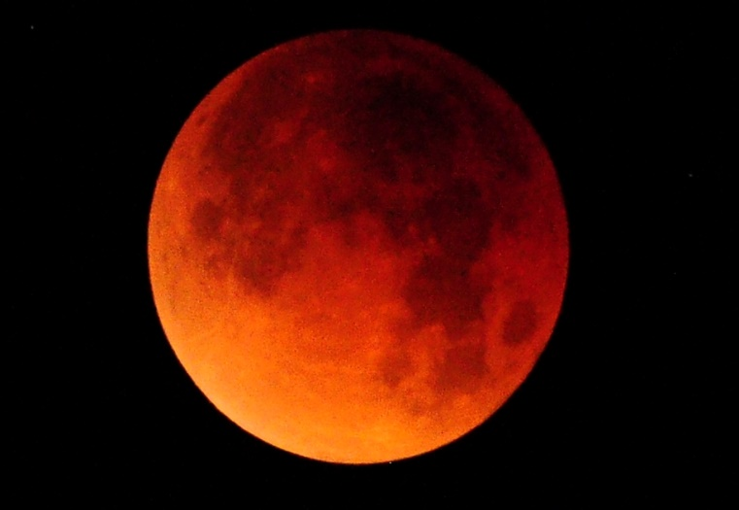

July Full Moon Run and Total Lunar Eclipse Week-end

Maroochy Moonlighters will hold the July Full Moon Run on Saturday 28th July at the country estate of Lollypom and Wet n Wild to celebrate the Total Lunar Eclipse out in “Deliverance Country”. Maps will be provided later.

Facilities are limited, so numbers will be limited to 40 persons. You need to be self-contained campers.

Registration fee is $10 per head for regular Moonlighters and $20 for irregulars.

Registrations close on 21st July to enable catering to be finalised.

Payments can be made to the following committee members:

Grand Master Lecherous (0409 815 389)

Hash Cash: Wet Check (0439 742 711)

Bank Account Details:

Registration fee will include:

28th: Post run Snacks and Drinks, BBQ Dinner (steak, sausages, salads or vegs), dessert and a limited quantity of beers and fine wines;

29th: Grader Drivers Breakfast (Bacon, Eggs, Sausages, Baked Beans, toast, coffee, tea, fruit juice).

Note: BYP plates, cups and cutlery etc.

Programme.

Saturday 28th:

12.00 Registrations,

14.00 Depart for Run and Walk

16.30 Apres Run, Circle and Bonfire

18.30 BBQ Dinner, more drinks, dancing etc. around the bonfire

Sunday 29th:

08.30 Heart-starters and Grader Driver’s Breakfast

10.30 Morning relaxation

12.30 PU&PO